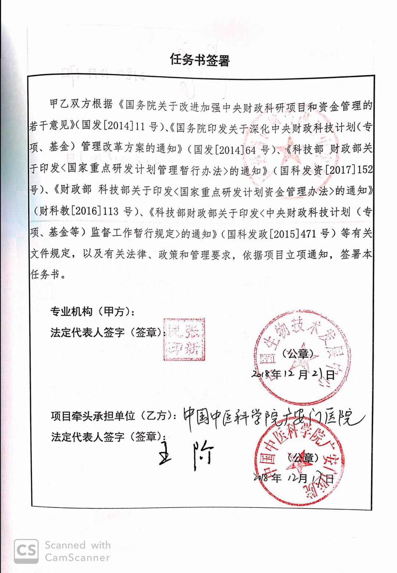
Translation
Project Contract
Both Unit A and Unit B are in accordance with the “Several Opinions of the State Council on Improving and Strengthening the Central Financial Research Projects and Fund Management” (Guo Fa [2014] No. 11) and the “Notice of the State Council on the Reform of the Central Financial Science and Technology Plan (Special, Fund) Management Reform Plan” ( Guofa [2014] No. 64), Notice of the Ministry of Finance and the Ministry of Finance on Printing and Distributing the Interim Measures for the Administration of National Key R&D Programs (Guo Ke Fa [2017] No. 152), and the Ministry of Finance Ministry of Science and Technology on Printing and Distributing <National Key Points Notice of the R&D Plan Fund Management Measures> (Financial Science [2016] No. 113), and the Notice of the Ministry of Finance and the Ministry of Finance on Printing and Distributing the Interim Provisions on the Supervision of the Central Financial Science and Technology Plan (Special Funds, Funds, etc.) (Guo Ke Fa Zheng [ 2015] No. 471) and other relevant documents, as well as relevant laws, policies and management requirements, according to the project notice, signed this project contract.

